Project Demonstration Phase

1. Introduction
The Project Demonstration Phase involves presenting the completed Script-Controlled ACL project to the project guide, faculty, or evaluator. The demonstration explains the project objective, ACL configuration, field-value-based access control, implementation, and testing results.

2. Objective
- To demonstrate the working of the Script-Controlled ACL.
- To explain how record access is controlled based on field values.
- To demonstrate authorized and unauthorized access scenarios.
- To present the project implementation and testing results.
- To show that the project meets the defined requirements.

3. Activities Performed
- Introduced the project and explained its objectives.
- Explained the requirement and access-control concept.
- Demonstrated the configured ServiceNow table and fields.
- Showed the Script-Controlled ACL configuration.
- Explained the ACL script and access conditions.

4. Expected / Produced Output
- Completed project successfully demonstrated.
- ACL configuration explained clearly.
- Field-value-based access restriction demonstrated.
- Authorized and unauthorized access results verified.
- Project workflow and testing results presented.
- Final working system demonstrated to the evaluator.

Screenshot

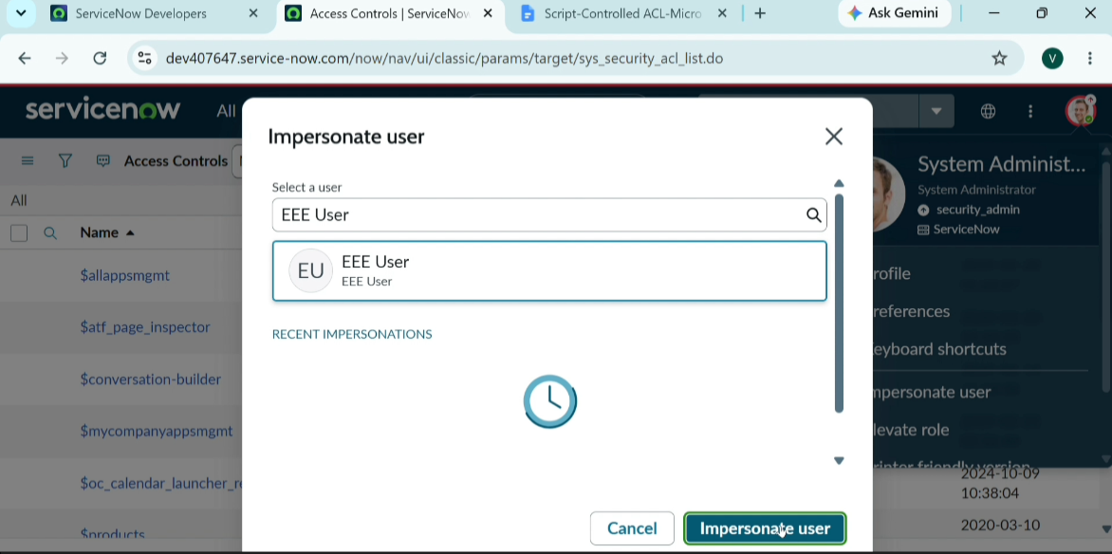
- Data Flow Diagram

